Title:

Design Metasystem research project - From Linear to Non-Linear processes applied in the improvement of creation and development of start-ups

Américo Da Conceição Mateus / Head of Research DELLI – Design Lusófona Lisboa

Susana Manuela Gomes Leonor / UNIDCOM_IADE_EU – IDEAS(R)EVOLUTION

Sofia Couto Martins / UNIDCOM_IADE_EU – IDEAS(R)EVOLUTION

Abstract:

Companies have sought to introduce new methodologies for business and project management and development.

In this perspective emerged the Design Thinking, a methodology focused on synesthetic aspects and organized in what have been called the mental process of designers within a creative bias.

However, Design Thinking has surpassed its original format becoming a business methodology focused on the empowerment of non-designers within a closed perspective in strongly structured and linear.

Our purpose is to return to the origins of how to design and enable the design thinking (r)evolution: Systemic, non-linear and meta-discipline, through methods, techniques and tools appropriate to start-ups.

Keywords: Design Thinking, System thinking, Meta-systems, Start-ups

INTRODUCTION

In the last years, an analysis of the processes where some answers and paths have been found have been made, according to Patter & Pastor, 2015 there are four phases of Design Thinking complexity (figure 1):

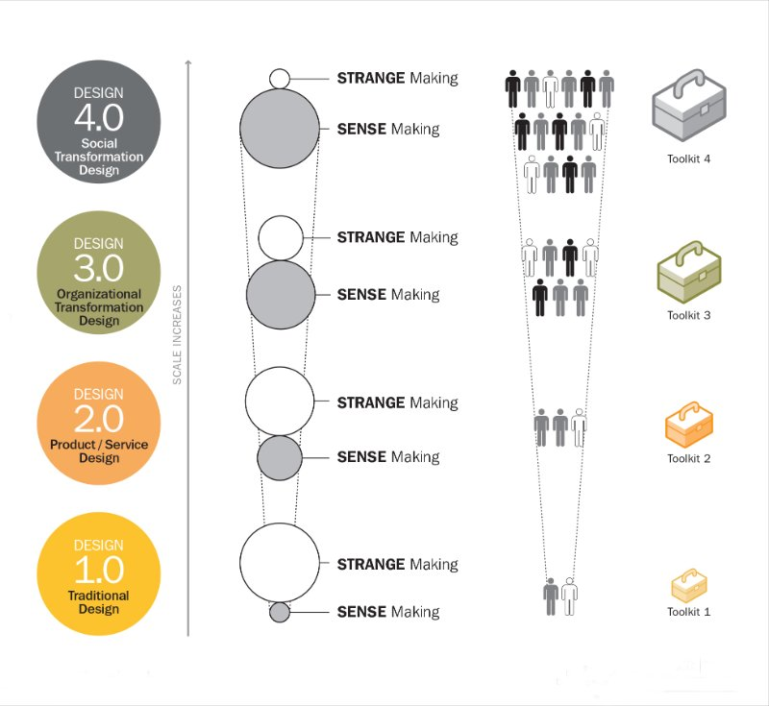

Figure 1: Design evolution phases

Source: Patter & Pastor, 2015

· A first phase focused on the design thinking process outcome or result, as developing innovative products and services;

· A second phase, more focused on process itself and how it could solve other type of innovation challenges, such as the social, technological and territorial areas;

· A third phase, more actual where organizations see design thinking processes as a main reference, model, process and set of tools for creating organizational culture oriented towards innovation.

· In a fourth phase, Design aligns itself as a central element in the structure, strategy and leadership form of organizations, creating more innovative organizations that define their own processes and subsystems according to the challenges, workers, and stakeholder’s involvement.

The Design Metasystem research project proposes to discuss and analyze these this four evolution phases trough the lenses of cognitive models:

* The DT1 *fits in deductive processes* - Postulate Then and test hypotheses, strong focus on experimentation.
* The DT2 fits in *induction processes* - Extrapolate from observations, which led to a deepening of the techniques and methods of observation.
* The DT3 fits *in abduction cases* - Imagine Scenarios que satisfy conditions which led to the focus on developing organisational structures and spaces that could enable creative and innovation culture like: Think Thanks, Corporate Garage, Genius coffee, internal start-up, etc...

Our Design Metasystem research project and conceptual model, propose to support this evolution towards the fourth Stage that DT4 is *related retro-abductive models* - Imagine Rules que lead to alternate Behaviours.

Only such focus may enable the necessary conditions for a true design thinking (r)evolution: non-linear and collaborative, through methods, techniques and tools appropriate to start-ups.

According to Banny Banerjee, 2008: “*Design is uniquely positioned to engage in complex multi-dimensional problems, and yet to do so effectively, there are many areas it needs to buttress itself in through collaborations with other fields. But in filling the gaps in its own methodologies, the bigger opportunity is for design to find ways of systematizing and expanding the nature of collaborations with other disciplines”.*

In the following figure 2, the author presents the evolution of Design, mainly with the Design thinking dissemination: (…) “*how core design practice became more generalized in applying “design thinking” to problems not traditionally considered within the purview of design. We are beginning to see multi-disciplinary collaborations take place across institutions and academic programs. Systematization of the rules of engagement between sets of discipline yields a trans-discipline. The process of creating trans-disciplinary paradigms attuned to a given class of problems would constitute a meta-disciplinary practice (…)”*

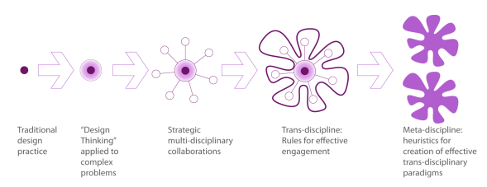

Figure 2: From traditional design practice to the Meta-discipline of Design

Source: Banerjee, 2008

AN EVOLUTIVE PERSPECTIVE ON DESIGN, INNOVATION AND START-UPS

Innovative efforts in organizations are increasingly drawing from the field of design. Cognitive processes, tools and methods underlying design practice are being employed to drive innovation, not only in industrial and consumer product firms, but also in the service industries such as healthcare, insurance, and banking (Brown, 2009; Liedtka & Ogilve,2011; Kolko, 2015; Vianna, Vianna, Adler, Lucena, & Russo, 2012).

This represents a substantial evolution in the field of design. Historically, design was treated as a downstream step in the product development process. Designers were primarily expected to provide late-stage add-ons to products to make them more aesthetically attractive.

Over the years, design has moved upstream, taking a greater role in adding value at earlier stages of the innovation process (Brown, 2009). Design evolution has been depicted by Richard Buchanan (2001) as moving from the first and second orders of design, dealing with graphic and industrial design, to the third and fourth orders of design-arenas of human interaction and environmental design, including organizational change.

Substantive innovation is accompanied by needs for organizational change (Junginger, 2007; Deserti & Rizzo, 2014). As design thinking increases its scope to more strategic aspects of organizational activity, the development of a greater understanding of organizational processes, including the complex issues underlying organizational change, is needed. For some time now, business discourse has identified that leaders with designerly approaches offer strategic and tactical advantages over those with approaches espoused and taught in traditional MBA and business leadership curricula (Brown, 2009; Liedtka, King, and Bennett, 2011; Liedtkaand Mintzberg, 2006; Liedtka and Ogilvie, 2011; Martin, 2009). To clarify designerly, we refer to Cross (2006, 2011) and his discussion of an approach to design that privileges discourse around and through making, aesthetic sensitivity, and human-centered perspectives.

In response to this, we have seen an uptake of design discourse and concepts in the traditional leadership curriculum. MBA programs (and business schools more widely) have adopted design as a point of differentiation in a crowded market (e.g., Rottman, Case Western, Oxford, Harvard Business School, Copenhagen Business School etc.).

Science, technology, engineering, and mathematics programs have reclaimed design skills and attitudes as a way of crossing silos and addressing ill-framed professional situations (e.g., Olin, MIT). Another response for building designerly capacity has been to house design on its own, structurally independent from institutional silos (e.g., dSchool, HPInstitute) or as a separate organizational entity, working in startup/incubator mode (e.g., AC4D, Strelka). Some initiatives by government agencies (e.g., British Design Council, Singapore Design Council, AIGA Designer of 2015, CIIC Valuing Australia’s Creative Industries) approach this issue from a designerly perspective, arguing for the value of awareness, use, and integration of design within traditionally separate industries. Concurrently, more traditional establishments of design education schools of art and design (e.g., California College of the Arts, School of Visual Arts) have extended their curricula to explicitly address topics of business, innovation, and leaders.

However, although all this effort has managed to raise the value of design and give it a prominent place in organizations, on the other hand the fundamental concepts of creative and collaborative work design have been forgotten, making the activity much more methodical and bound to rules that Show very similar results in all processes of Design Thinking applied in companies (Christ, 2013). So, the vast majority of businesses end up presenting similar results, repetitive formats and solutions that are no longer of disruptive innovation but rather of process improvement or usability.

Design, in its broadest possible sense, can help us to integrate the remarkable wealth of specialized knowledge, skill and shared aspiration that rests within humanity. Design should not be considered a specialized field of human endeavor but it can be understood as the integrative activity that connects human intentions to their material and cultural expression in the form of artefacts, institutions and processes (Walh, 2016).

The idea of linearity of thought is no longer conceived, as it has been used for a long time, the contemporary professional can no longer follow linear directions. It needs to incorporate different areas of knowledge to contextualize its performance, making it more comprehensive (Gomez, 2005). Mainly, in the space of construction of new innovative enterprises as is the case of start-ups.

This new way of starting companies called start-up has been growing worldwide and in Europe and Portugal has considered as a "friend" country of start-ups. According to official documents the Start-Up Portugal Program (www.startupportugal.com), the strategy of the Government of the Republic for Entrepreneurship. Rather than fostering an entrepreneurial spirit, it is designed to support those who are already entrepreneurs, to ensure the longevity of the businesses created and to increase their impact on job creation and economic value.

It is designed to organize, unblock, promote sharing of benefits, good practices and resources, understand where there are regional and sectorial failures and fill gaps. In order for such actions to take place, it is necessary to review the methodological processes that have been applied, whether in large or small companies, in a contemporary way, focused on the innovative results and not on magic formulas that are fixed in filling pre-determined boxes in Design empowerment books rather than the reality of systemic, collaborative, and transdisciplinary thinking that design can apply.

DESIGN METASYSTEM RESEARCH PLAN

As described in the literature, the methodologies, mainly design thinking and lean start up, have been relatively successful in their applications, mainly by the implementation model that transforms all the processes in one or more canvas with boxes to be fulfil by consultant and methodology teacher. In this sense, this research aims to revisit all presented methodologies.

With the real perspective of design, not of empowerment but of collaborative and non-linear work, which adapts to the real needs of each star- up in which the process will be applied. Within classic theories of nonlinearity design and collaborative work this project aims to develop methods, techniques and tools that support, the creation and innovation in products / services and management of start-ups.

To proceed with this research, we first discuss the process of project that is largely viewed as a collaborative, interdisciplinary activity that is more flexible than some of the approaches that emerged during the 1970s and 1980s (Martins, Cruz Rodrigues & Mateus, 2016). Design research has assumed its articulation between the different disciplines and reflection on the knowledge developed (Leonor, 2016). Dissipating boundaries that separate the different scientific areas and integrating different disciplines into the object of study brings other perspectives, methods, new knowledge and results that can fulfil the gaps in other research areas (Alexander, 1964).

This research will develop by the Design-based Research (DBR) that has been gaining expression since the end of the 20th century. The research method has is origins in the education research field (Anderson and Shattuck, 2012), which is why it was considered its use in the present research, that is based on pedagogical proposals for the scenario of application. A DBR consists of "a systematic but flexible methodology aimed to improve educational practices through iterative analysis, design, development, and implementation, based on collaboration among researchers and practioners in real-world settings, and leading to contextually-sensitive design principles and theories" (Wang e Hannafin, 2005, p. 6).

Unlike traditional research methods, DBR is not based on the formulation of hypotheses but rather on the analysis of practical problems in collaboration and the development of solutions based on existing design principles and technological innovations.

Barab and Squire (2004) argue that the distinction between DBR and action research is that "the project is designed not only to meet local needs, but to advance a theoretical agenda, to discover, explore, and confirm Theoretical relations "(Barab and Squire, 2004, p.5). Therefore, the main objective of the present research was not only to meet the needs of a scientific context, but to discover, advance and confirm theoretical relations woven in the context of the reality of start-ups, which in the future can be extrapolated to other contexts.

In search of integration of theoretical, conceptual and methodological approaches in the construction of a new evolutionary design model, the four Scientific Areas were focused:

* Social Sciences;
* Life Sciences;
* Natural Sciences and
* Technological Sciences.

In detail, we will apply a mixed of research methods and tools, based on IDEAS(R) overall methodology, aligned with the proposed research tasks in order to achieve the project objectives, mainly Model Building, Action research and Living Lab.

Research Steps / Tasks:

The 1ª task - INVOLVEMENT - Gathering information:

Its diagnostic and survey stage. We will survey the best indexed international databases in the focused knowledge areas: Design, Entrepreneurship, Startups Theory, Innovation and Process.

The 2ª task –INSPIRATION - Fieldwork observation

It’s about understanding and defining. ethnographic, anthropological observation techniques and in-depth survey to retrieve information. A set of mixed methods and techniques will be used to obtain quantitative data and qualitative data. During this process, we will use video and photography recording as well as ethnographic surveys in order to obtain the activity perceived value and critical success factors identification. This research will provide us a comprehensive understanding about these topics for the development of the good practices and information to present to the experts group.

The 3ª task – IDEATION - co-creation workshops

A set of co-creative workshops with scientifically recruited stakeholders that will certify the study representativeness and results validation. With a wide set of stakeholders to study since Designers, design schools, professors, start-ups entrepreneur’s, business people, leaders, opinion makers and legislators, trend setters, students, researchers from different areas, users, consumers. We will use a set of workshops of ideation, experimentation and consensus, creative tools and techniques developed by the research group and widely published (MATEUS et all, 2010; 2011; 2012; 2013; 2014).

The 4ª task – INTEGRATION – external validation and consensus

It will be performed the external validation and the strategically systematization phases of the IDEAS(R) process. We will use set of tools and methods as GAP analysis and Delphi consensus rounds. This stage is crucial to obtain valid data from the ideas for the innovative development of Designer/Artist obtained in the last stage. With the best ideas, practices, parameters, principles will be submitted to consensus rounds from the stakeholders group through DELPHI (consensus generation technique) rounds and further presented to an external group composed by triangulation of three sub-groups: (a) Start-up entrepreneur’s; (b) Management experts and (c) Designers (Thinker designers). Through GAP analysis technique we will find common points between the three evaluation panels as well as the divergent ones. These techniques will have the main objective obtain data about perceived value of our conceptual Model. In the end of this process will be performed 3 DELPHI rounds to solve gaps or differences and generate consensus. We also can use the TRIZ technique to solve non-or hard consensual solutions. This research will enable to improve and design the final Model regarding practice, pedagogy, methodology and tools.

The 5ª task – IMPLEMENTATION - proof of concept living lab

It will be performed and implemented a proof of concept test according with Living Lab methodology (Enoll, 2007). We want to test the final concepts and the developed good practice manual. The living lab methodology will be applied during six months and living lab design will be the following: (a) candidate's start-ups selection for the lab; (b) candidate start-ups training and manual delivering; (c) will be given the same working conditions to all the candidate star ups; (d) the project team will keep up as observers of the implementation process and the development to register the applied the processes, practices and methodologies; (e) it will be asked to each start up participant to implement / develop a new product/service/process generated by the past tasks; (f) in the final will be analyzed the experience data according with, survey parameters data in order to compared the final answers with the initial applicants knowledge. During this stage, we will also implement a pilot quasi-experimental research related with the pedagogical aspect. The pedagogical component of the operation manual will be used by our international research partners in their design projects classes. This manual will be implemented according the following phases: (a) selection of national and international universities for participation; (b) knowledge transfer through the manual and training; (c) observation via technological or class recording in three crucial semester moments; (d) student’s evaluation through practical projects; (e) information sharing and peer evaluation of the professors from the different universities.

The 6ª task – INTERACTION – Model Finishing and dissemination

It’s the research project results and findings dissemination stage. Based on Solis (2012) social media 6 stages strategies. These channels will be used to communicate our results and finding not only for the academic community but specially to the games developers community. We will activate the online social media as Facebook, Linkedin, ACADEMIA.EDU; Ted Ed, as well as the activation of the open access collaborative platform.

MAKING THE CASE FOR DESIGN METASYSTEM

Design, in its broadest possible sense, can help us to integrate the remarkable wealth of specialized knowledge, skill and shared aspiration that rests within humanity. Design should not be considered a specialized field of human endeavour; rather, it can be understood as the integrative activity that connects human intentions to their material and cultural expression in the form of artefacts, institutions and processes. (Walh, 2016)

System Thinking approach

Our research project conceptual model focuses precisely on the systemic and integrative value of design for all organizations, for the market and the economic development of society.

In contrast to traditional forms of leadership, we reframe leadership as a modality as well as a mindset, and emphasize the need to define it as a capacity to create impact in an increasingly complex class of challenges. Innovation Leadership involves two main dimensions of change namely the ability to amplify the impact and the ability to amplify the Innovation Capacity of the system (Benerjee et Al, 2016).

Within a complex system, efforts focusing on isolated problems within the larger system are of little use to decision makers. System approaches – engineering models, analysis platforms, and assessment tools predominantly targeting tightly defined engineered systems – have been applied to help landscape design and management since the 1960s (Chang et al. 2011). it is fundamental to understand “systems” – not just the definition of the term as “a group of interacting, interrelated, or interdependent elements forming a complex whole” – but what Meadows (2008) has called “Thinking in Systems”.

System thinking in design means designers have to understand the intrinsic connections between habitats and the extensive matrix of human-dominated uses, suggesting unexplored problems and potentials for change, such that a design thinking focused on change model could be proposed and its impact be evaluated as we propose.

Socio-technical systems theory has enjoyed around 60 years of development and application internationally by both researchers and practitioners (e.g., Baxter and Sommerville, 2011; Levin, 1999: Levy, 2000; Simon, 1996; Cherns, 1976, 1987; Clegg, 2000; Eason, 1988, 2007; Prigogine, 1997; Pasmore and King, 1978; Trist and Bamforth, 1951; Waterson, 2005). The over-arching philosophy, embracing the joint design and optimization of organizational systems (incorporating both social and technical elements), has maintained its practical relevance and has seen increasing recognition and acceptance by audiences outside the social sciences (Eason, 2008). Such successes can be attributed, in part, to the continuing evolution of socio-technical systems thinking and practice.

The core philosophy of sociotechnical systems theory, namely that **“**design is systemic**”** (Clegg, 2000, p. 465). The theory advocates consideration of both technical and social factors when seeking to promote change within an organization, whether it concerns the introduction of new technology or a business change program (Cherns, 1976). Organizations can be considered complex systems, comprising many interdependent factors. Designing a change to one part of the system without considering how this might affect, or require change in, the other aspects of the system will limit effectiveness (Hendrick, 1997).

System thinking principles applied to Design Metaystem Model

The designed model also draws on methods from system dynamics theory such as system analyses and causal loop wrapping and loop analyses in order to understand system dynamics (Senge, 1990; Sterman, 2000; Haraldsson & Sverdrup, 2004; Sverdlup et al, 2014). System analysis is used to map causalities involved in the processes studied. These causal loop diagrams constitute knowledge-maps for the system, and these are iteratively tested against data, experiences and qualitative information in a “learning loop model”. The system analysis process becomes an iterative adapting learning process (Senge 1990). When non- researchers are present, such as stakeholders or students, then these are included in the in the process, the term for this is an adaptive social learning process, a powerful participatory pedagogical tool.

Main, literature based, founding Design Metasystem building blocks:

* A "meta-system" is a system about other systems, such as describing, generalizing, modelling, or analyzing the other system(s).[1]
* "Autopoiesis" (from Greek αὐτo- (auto-), meaning "self", and ποίησις (poiesis), meaning "creation, production") refers to a system capable of reproducing and maintaining itself (Maturana & Varela, 1980)-
* Adaptive system is a set of interacting or interdependent entities, real or abstract, forming an integrated whole that together are able to respond to environmental changes or changes in the interacting parts (Wotherspoon & HüBler, 2009)
* Metamodeling or meta-modeling is the analysis, construction and development of the frames, rules, constraints, models and theories applicable and useful for modeling a predefined class of problems (Jeusfeld, & Mylopoulos, 2009)
* New level of systems - Models, Processes, Tools, Platforms and Techniques for trans-disciplinary co-creation. Finding new perspectives on re-defining the problem, spotting new types of opportunities to propose new higher level of possibilities and solutions to the new problems (Tapscott et al, 2017)
* Cognitive Model - cognitive and rational support the Design Metasystem approach is *retro-abductive model* - Imagine Rules that lead to alternate Behaviors (Benerjee, 2012).

This Design Metasystemic-based approach will not only help us to integrate many different perspectives and disciplines, it will also remind us that for the transition to be effective it will have to include not just a sound scientific basis informed by systemic thinking, but also ethical, aesthetic, social, cultural, economic value research pillars.

Our goal is to regenerate the Design approach and build models, methods and tools and transfer them to all type of organizations to help them to have better leadership model's fitter with the emergent complexity of now-a-days. The Era of People and the Spirit of Collaboration requires a cultural change in management. Collaboration is vital not just because it´s a better way to teach and train people, but because learning to collaborate is an intrinsic part of providing efficiency, issue resolving and lifetime learning in an ever-changing interlinked economy (Tapscott, 2013).

Our aim is to deeply research all the relations and co-relations between all Design Sub-systems in order to create the operative models that focus on providing a deeper support to each different given problem. By shifting from linear Design approaches and processes to non-linear one’s we aim to reach higher Design valorization within any organizational context, Design becomes then an intrinsic value for the all organization and aims to be placed at the center of its leadership (Hamel, 2012; Amabile et al., 2011), and transforming the business organizations into communities of interest and communityship (Mintzberg, 2012) with all its stakeholders, listening and dialoguing constantly, acquiring new criticisms and insights for their sustainable development and innovation.

Based in these principles, the focused research outcomes Range and Scope are:

* Design Thinking Evolution from Linear to non-linear processes
* Mapping cross-knowledge areas, emergent concepts that will Drive the Model building
* Building new Design Systems, Models, Methods and Tools adaptable to different application contexts and challenges.
* Design metasystem model aims to be a toolkit and Strategic reference to the role of Design for Leadership, as well as, a understood intrinsic economic value for the Business organizations
* Business, Territories, Communication Systems, Learning and Educational and Spatial
* Applied Research, Develop and Validate the Metasystem approach with Action Research, Model Building methodologies.

PRE_RESEARCH MODEL

Resilience thinking and whole-systems thinking are crucial skills for Metasystems designers. So how do we design for positive evolution? One way is to support the ability of a complex dynamic system to keep adapting, learning and responding to internal and external changes. We started by combined in the non-linear approach the following scientific areas: Processes, Project, Evolutionary, Organizational, Learning and Technology.

Our proposal is a conceptual model (figure 3), that is divide in three parts:

1. Back to basics: DESIGN Processes and Project thinking
2. New Domains: Technology and Organizational Knowledge
3. Disruptive Elements: Evolutionary theories and Learning Competences & Spaces



Figure 3: Design Metasystem Conceptual Model

Source: The authors 2017

FIRST RESEARCH IMPLEMENTATION FINDINGS FROM PRE_EXPERIMENTAL PILOT CASE

At the present stage, our research team already implement the firsts two stages / tasks of the first pre-experimental pilot case – INVOLVEMENT and INSPIRATION.

This pilot took place in the PLAY, incubator for the creative industries of the University Lusófona of Lisbon. We made two activation sessions with different stakeholders, in addition to the entrepreneurs from Play, we call opinion makers, trend setters, successful local start-ups, investors, academics, designers, Lisbon Municipality leaders for entrepreneurship Strategy, coworkers space owners and students in general.

Based on the collected information and the ethnographic fieldwork observation, mainly the interviews with the different stakeholders and the group dynamics workshops gathered information, we already needed to improve the Pre-conceptual model before going further with the pre-experimental pilot case.

We introduce a better visualization of the sub-system / areas and developed an operational proposal to implement the model.

The improved is based on the Why, How and what, the Sinek (2011) “Golden Circles” approach:

Feedback/Action table 1:

|  |  |  |
| --- | --- | --- |
|  | FEEDBACK | ACTION |
| 1 | The stakeholders felt the need to have a better understanding of the Model Purpose and essence. | Be clearer about the essence of the model – In the central area we introduced the big WHY, that is to create: (a) creative Culture; (b)Fitness/ Adaptability and (c) Openness / Mindset & Attitude |
| 2 | The stakeholders felt the need to understand better the design challenges typologies, meaning how the challenge starts and how the solutions implementation happens | We created a second layer that represents the HOW - possible Design challenge “entering and exit doors” and organized an clear vision on the three focused areas of the model: (a) “Hardware” / Processes and Organization; (b)“Software” / Project and Technology and (c) “Humanware” / Learning and Change |
| 3 | The stakeholders told us that they needed more guidance through-out the model to know the areas and what to do in each of them | We introduced new sections on the model that represents the WHAT – Focused areas to act: (a)Leadership, Relations, Interactions and Experiences; (b) Networks, Information, Materiality and Tangibility and (c) Cognition, Bias, Acquisition and Integration |

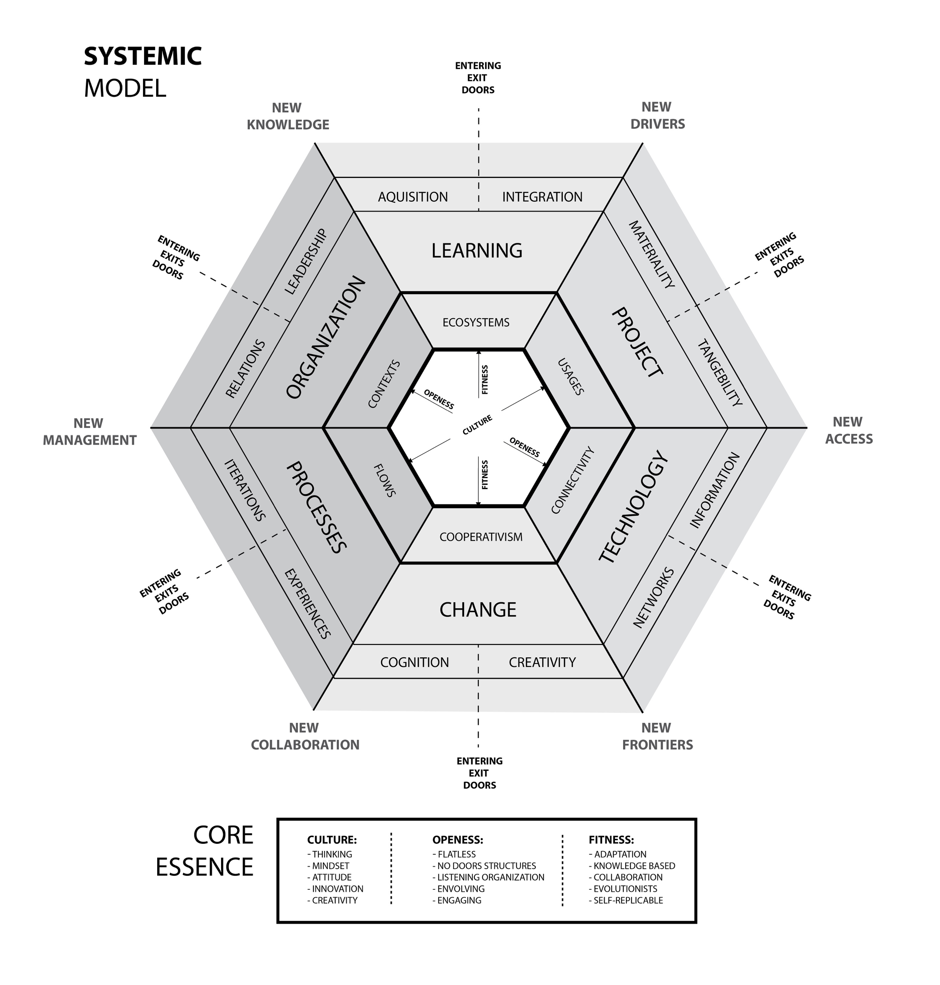

Figure 4: The Improved conceptual model – DELLI Metasystem Model

Source: The authors, 2017

The Interviews and observations all highlighted the need to visualize an operational version (see figure 5) of the conceptual model, meaning, the phases of development / implementation.

Following the continuous literature review and the fieldwork feedback, we created four operational Phases:

* Diagnostics – Initial surveys, all company interviews and group dynamic sessions;
* Critical Projecting – System thinking based tools to gather information and problem/opportunities definition;
* Systemic Solutions – Design tools to look at the parts and the sum of parts to generate integrated new solutions for the innovation challenge;
* Impact Metrics – quali/quanti metric system along the process and during implementation to control, monitor and improve the solution in real life context.

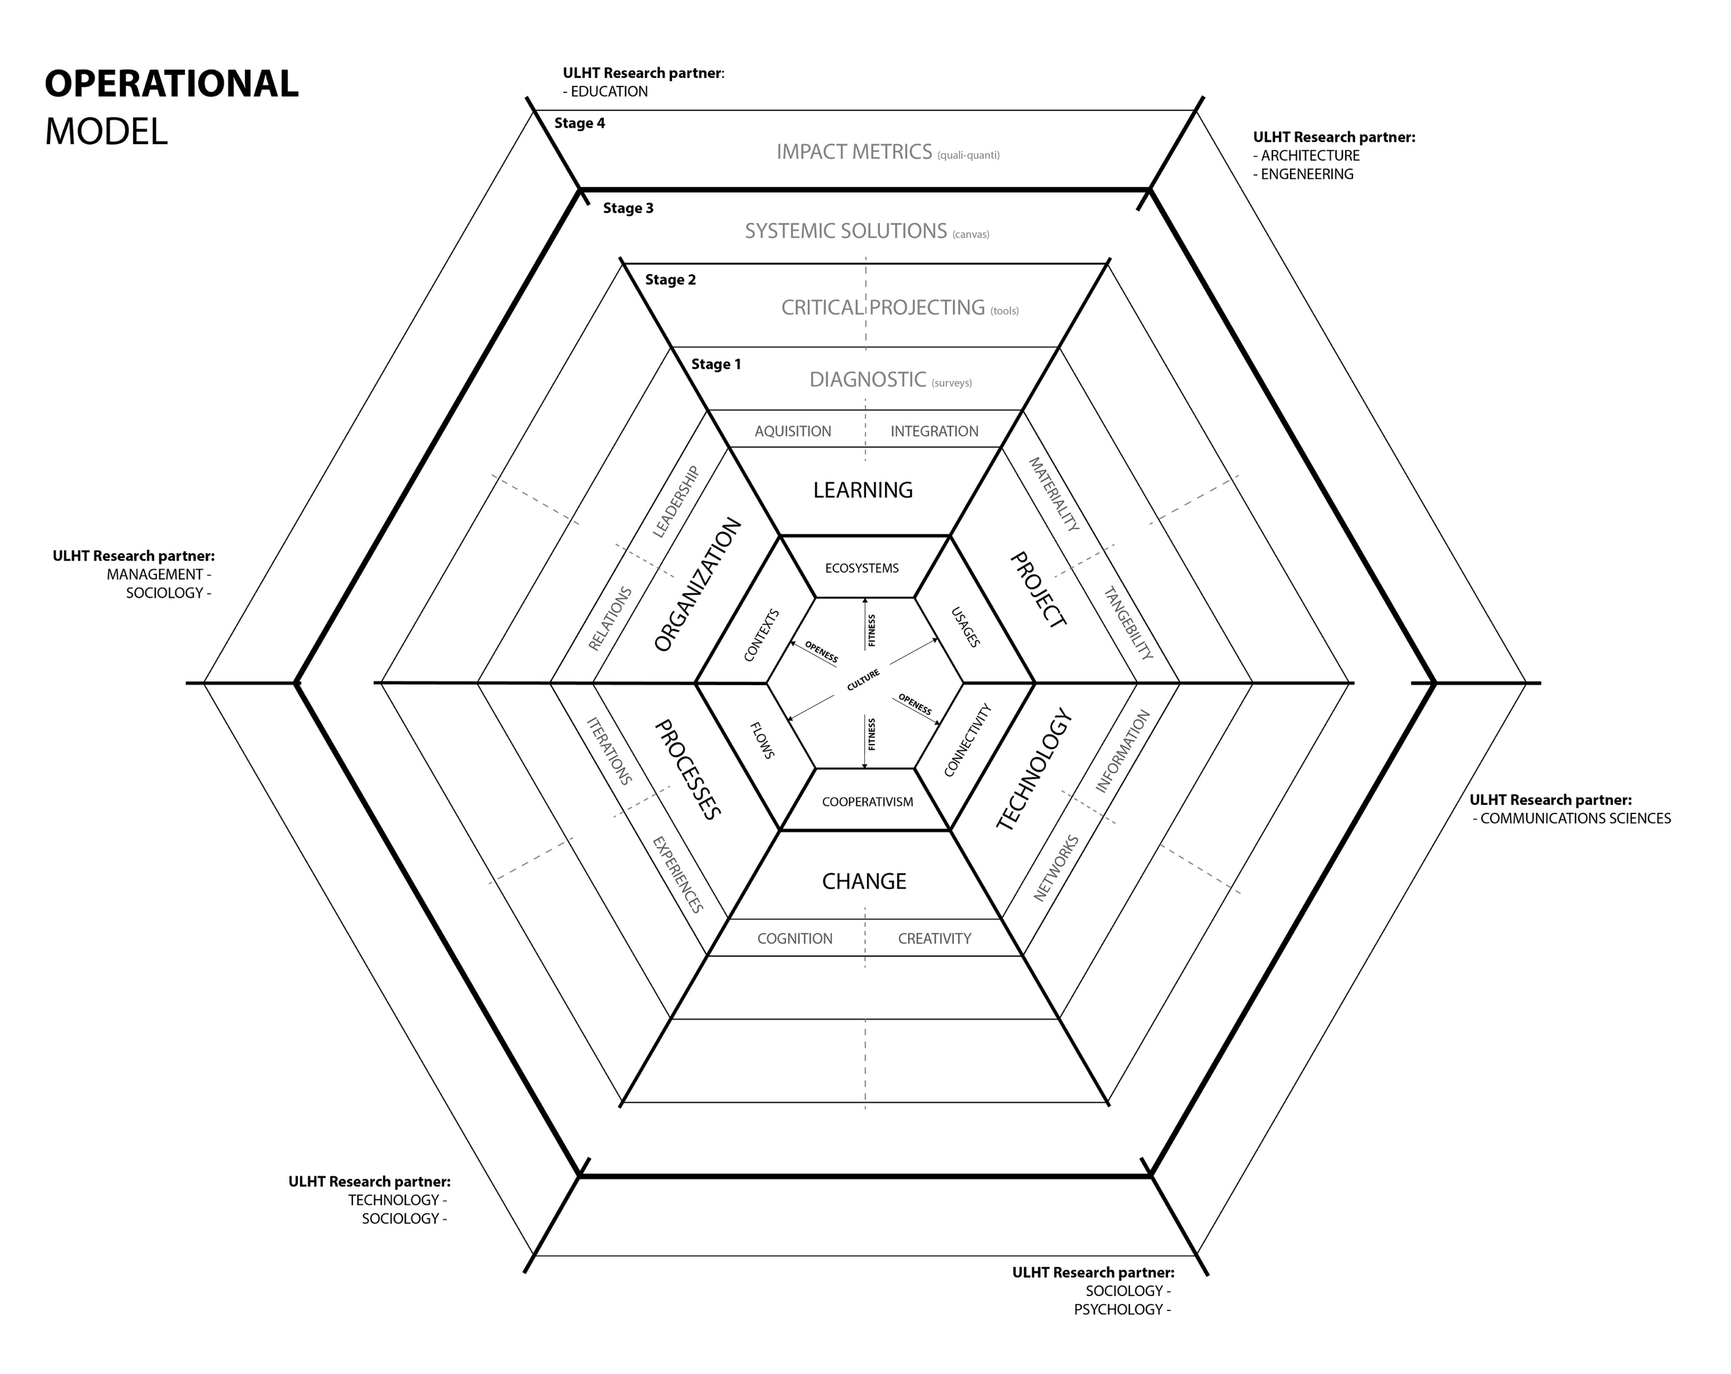

Figure 5: DELLI Metasystem Operational model

Source: The Authors, 2017

CONCLUSION

The creation of an aspirational, explorative, transdisciplinary Design Metasystem research project and applied model has been no doubt challenging, but a “natural” evolution for a Design Thinking methodology research group such as our research group IDEAS(R)EVOLUTION. We needed to give a few steps forward by attracting people that represent diverse knowledge areas, institutions and even different roles. We have been working collaboratively with neuroscientists, psychologists, experts on education, learning, organizations systems, management, marketing, social scientists, biologists and of course Designers and Entrepreneurs.

We are still on the “beginning of our journey”, but these initial baby steps are crucial. From the research design and plan, to the pre-experimental pilot cases allowed us to have already created and improved our pre-conceptual model.

Using applied research and model building methods implies to create, test, make mistakes, improve and create again until the process validates the model that we are building.

We are now on the stage of starting a pre-experimental pilot case within our international network, starting in Brazil in order obtain insights and feedback of the propose pre-conceptual model.

REFERENCES

AMABILE, T., & KRAMER, S. (2012). What Makes Work Worth Doing? Retrieved from Harvard Business Review: http://blogs.hbr.org/2012/08/what-makes-work-worth-doing/

BANERJEE, B. **DESIGNER AS AGENT OF CHANGE, A Vision for Catalyzing Rapid Change.** International conference on the role and potential of design research in the transition towards sustainability, USA: Stanford University, 2008.

BANERJEE, B., CERI, S., & LEONARDI, C. (2016). Innovation Leadership: A New Kind of Leadership.

BARAB, S., & SQUIRE, K. Design-Based Research: Putting a Stake in the Ground. **Journal of the Learning Sciences***,*13, 1, 1-14, 2004.

BAXTER, G., & SOMMERVILLE, I. (2011). Socio-technical systems: From design methods to systems engineering. *Interacting with Computers.*23, 4-17.

BROWN, T. & MARTIN, R. Design for Action. **Harvard Business Review**, p. 56-64, 2015.

BROWN, T. **Change by design: How design thinking creates new alternatives for business and society.** New York: Collins Business, 2009.

BROWN, T. Design Thinking. **Harvard Business Review**, Vol 86, No. 6, pp 84-92, 2008.

BUCHANAN, R. Design Research and the New Learning. **Design Issues**, Vol 17, No 4, p.3-23, 2001.

CHANG, N. B., Pires, A. & Martinho, G. (2011), Empowering systems analysis for solid waste management: challenges, trends and perspectives**. Critical Reviews in Environmental** **Science and Technology**, 41 (16), 1449-1530**.**

CHERNS, A., 1976. The principles of sociotechnical design. **Human Relations 29** (8), 783**e**792. <http://dx.doi.org/10.1177/001872677602900806>.

CLEGG, C.W., 2000. Sociotechnical principles for system design. **Applied Ergonomics** 31 (5), 463/477. http://dx.doi.org/10.1016/S0003-6870(00)00009-0.

CLEGG, C.W., SHEPHERD, C., 2007. The biggest computer programme in the world ever!: time for a change in mindset? **Journal of Information Technology** 22, 212/221 http://dx.doi.org/10.1057/palgrave.jit.2000103.

DESERTI A, RIZZO, F. **Design and organisational change in the public sector**. Des Manag J 9(1), p.85–97, 2015

DESERTI A., RIZZO F., Design and the Cultures of Enterprises. **Massachusetts Institute of Technology**, Design Issues: Volume 20, Number 1 Winter, p. 43-51, 2014.

EASON, K., 1988. Information Technology and Organizational Change. **Taylor & Francis**, London.

EASON, K., 2007. Local sociotechnical system development in the NHS national programme for information technology. **Journal of Information Technology** 22, 257**e**264. <http://dx.doi.org/10.1057/palgrave.jit.2000101>.

HAMEL, G. (2012). What matters now. **Strategic Direction**, 28(9).

HARALDSSON, H.V., SVERDRUP, H. (2004) . Finding Simplicity in Complexity in Biogeochemical Modelling. **J. Wiley and Sons Ltd**., Chichester, pp. 211-223.

HENDRICK, H., 1997. Organizational design and macroergonomics. In: Salvendy, G. (Ed.), Handbook of Human Factors and Ergonomics. **John Wiley & Sons**, New York, pp. 594**e**637. Hodgkinson, G.P., Healey,

JEUSFELD, M., JARKE, M., & MYLOPOULOS, J. (2009). *Metamodeling for method engineering*. Cambridge, Massachusetts, **The MIT Press**. http://mitpress-ebooks.mit.edu/product/metamodeling-for-method-engineering.

JUNGINGER, S. Learning to design: giving purpose to heart, hand and mind. **Journal of Business Strategy**, Vol. 28 Issue: 4, p.59-65, 2007.

JUNGINGER, S. Product Development as a Vehicle for Organizational Change. **Design Issues**, Vol 24, No. 1, p. 26-35, 2007.

KOLKO, J. **Design comes of age**. HBR: 2015.

LEVIN, S. A. (1999), Fragile Dominions: Complexity and the Commons**. Perseus Books,Reading.**

LEVY, D. L. (2000), Applications and Limitations of Complexity Theory in Organizational Theory and Strategy. **In: RABIN, J., MILLER, G. J. & HILDRETH, W. B. (Eds), Handbook** **of Strategic Management (2nd Ed).** Marcel Dekker.

LIEDTKA, J. AND OGILVIE T. **Designing for Growth: A Design Thinking tool Kit for Managers**, Columbia: Business School, New York., pp. 35-50, 2011.

LIEDTKA, J. KING, A., & BENNETT, K. **Solving problems with design thinking: 10 stories of what works**. NewYork: Columbia Business School, 2013.

MARTINS, S.; MATEUS, A., RODRIGUES, A. Next steps for modelling the conceptual model of evolutionary design. **DDC17, Doctoral Conference at IADE**, Lisbon, 2017.

MATEUS, A. **Product / Brand co-creation methodology crossing Marketing, Design Thinking, Creativity and Management: IDEAS(R)EVOLUTION** (Doctor Europaeus dissertation). Évora: Universidade de Évora, 2016.

MATEUS, A.; LEONOR, S. Contribution to the integration of parametric processes as a method in conceptual and creative Design. **CUMULUS conference,** Santiago do Chile, 2012a.

MATEUS, A.; ROSA, C. Creative Intelligence methodology IDEAS(R)EVOLUTION: A proposal for two new stages of the design thinking process when applied to territorial innovation through an activation platform for ”Dialog with the Tribe”. **Senses & Sensibility IADE conference**, Lisbon, 2011a.

MATEUS, A.; ROSA, C. Oeste Ativo Ecosystem for Innovation: a regional business regeneration program through the design thinking based methodology IDEAS(R)EVOLUTION – a Co-creative way of thinking brands and integrated innovation. **CUMULUS conference,** Santiago do Chile, 2012b.

MATEUS, A.; SALOMÃO, L.; FERREIRA, A. Ideas [R]evolution methodology: Practical considerations based on two case studies. **CUMULUS conference,** Paris, 2011b.

MATEUS, A.; SALOMÃO, L.; FERREIRA, A. IDEAS(R)EVOLUTION - Transdisciplinary design thinking workshops for remarkable and innovative brand value. **Cumulus Conference**, GENK Belgium, 2010.

MATEUS, A.; SALOMÃO, L.; ROSA, C. Territorial Branding – Dna Alvito. **CUMULUS conference,** Santiago do Chile, 2012c.

MATEUS, A.; SOUSA, A.; SILVÉRIO, M. Plataforma Avançada para a Activação Territorial Land (R)evolution – the cellular system model. **XXII Conference Portuguese-Spanish of business Management and Economics**, organized by ETEA, Cordoba, 2011c.

MATEUS, A.M., ROSA, C.A, LOUREIRO, A. & LEONOR, S. A methodology for appraisal and validation of User Centered Open Innovation Programs: a case study critical analysis of an energy supplier co-creative innovation program. In J. B. Reitan, P. Lloyd, E. Bohemia, L. M. Nielsen, I. Digranes, & E. Lutnaes (Eds.). **DRS CUMULUS OSLO 2013 Design learning for tomorrow – Design** **education from kindergarten to Ph.D: Proceedings from the 2nd International Conference for** **Design Education Researchers - Vol3,** Oslo: ABM, p. 1633-1651, 2013.

MATURANA, H. R., & VARELA, F. J. (1980). *Autopoiesis and cognition: the realization of the living*. **Dordrecht** [u.a.], Reidel.

MINTZBERG, H. (2012). It's time to rebalance our sectors and society. Retrieved from The Guardian: <http://www.theguardian.com/sustainable-business/blog/government-corporations-rebalance-sector-society>

MINTZBERG, H. (2013). Simply Managing: What Managers Do and Can Do Better. Berrett-Koehler and Pearson.

PASMORE, W.A., KING, D.C., 1978. Understanding organizational change: a comparative study of multifaceted interventions. **The Journal of Applied Behavioral Science** 14 (4), 455**e**468. http://dx.doi.org/10.1177/002188637801400402.

PRIGOGINE, I. (1997),The End of Certainty: Time, Chaos, and the New Laws of Nature**.** **Free Press,** New York.

SENGE, P., (1990). The fifth discipline, the art and practice of the learning organisation, Century Business, New York.

SINEK, S. (2011). *Start with why: how great leaders inspire everyone to take action*. New York, **Portfolio/Penguin**.

SIMON, H.A., 1996. The Sciences of the Artificial, third ed. **MIT Press**, Cambridge, MA.

SVERDRUP H. (ED.), HARALDSSON, H., KOCA, D., BELYAZID, S. 2014 System Thinking, System Analysis and System Dynamics: Modelling Procedures for Communicating Insight and Understanding by Using Adaptive Learning in Engineering for Sustainability. **Háskolaprent Reykjavik**. 310pp.

STERMAN, J.D., (2000). Business Dynamics, System Thinking and Modeling for a Complex World, **Irwin McGraw-Hill**, NewYork.

SOLIS, B. **The End of Business as usual**. Hoboken (New Jersey): John Wiley & Sons, 2012.

SUCIU, C.; BAUGHN, C. **Design Thinking and Organizational Change: Developing a Human-Centered Culture.** USA: Boise State University, 2016.

TAPSCOTT, D. (2013). The spirit of collaboration is touching all of our lives. Retrieved from The Globe and Mail: <http://www.theglobeandmail.com/commentary/the-spirit-of-collaboration-is-touching-all-of-our-lives/article12409331/>

TAPSCOTT, D., TAPSCOTT, A., & CUMMINGS, J. (2017). *Blockchain revolution*.

TRIST, E.L., BAMFORTH, K.W., 1951. Some social and psychological consequences of the longwall method of coal-getting: an examination of the psychological situation and defences of a work group in relation to the social structure and technological content of the work system. **Human Relations** 4 (1), 3/38. http:// dx.doi.org/10.1177/001872675100400101

VAN PATTER,G.V. **Making sense of: “Why Design Thinking Will Fail”**. Retrieved 15 December, 2015.

VIANNA, M.; VIANNA, Y.; ADLER, I. K.; LUCENA, B.; RUSSO, B. **Design Thinking Inovação em Negócios**. Rio de Janeiro: MJV Press, 2012.

WAHL, D. C. Designing regenerative cultures. England: **Triarchy Press**, 2016.

WATERSON, P.E., 2005. Sociotechnical design of work systems. In: Wilson, J.R., Corlett, N. (Eds.), Evaluation of HumanWork, third ed. **Taylor & Francis**, London, pp. 769**e**792. http://dx.doi.org/10.1201/9781420055948.pt5.

WOTHERSPOON*, T., & HÜBLER, A. (2009). Adaptation to the Edge of Chaos with Random-Wavelet Feedback. **The Journal of Physical Chemistry** *A.*113, 19-22.

YUILLE, J., VARADARAJAN, S., VAUGHAN, L., & BRENNAN, L. Leading Through Design: Developing Skills for Affinity and Ambiguity. **Design Management Journal**, Vol. 9, Chap.1, p.113-123, 2014.

1. (n.d.). *Principia Cybernetica Project Web Page*. Principia Cybernetica Project, Free University of Brussels. http://pespmc1.vub.ac.be/.